Name:________________________ Period:___________
Activity Sheet T3–1e Review 5
1. Order Least to Greatest: {–325%, –π, –3½, – 3.14, –3⅔} 2. Calculate the MAD: {–8, 1, –5, 8, –4, –1, 5, 13, 9}
______________________________ _________________________________

3. Set A {5¼, 2, –π, 6.6, √8, 0,-5}: ⊂ B {w} =________________ 4. √89 = ____________
70⁰

5. 186,000,000 = _____________________ 6. Find x: x 150⁰
(in scientific notation)

7. –2(– x + 8) – (–4x ) = 5(3x + 6) x= _________ (For # 6.) x=________⁰

8. Jose bought tickets for $38 and also bought snacks ‘s’ to 2 events, the first event cost ‘s’ plus $2, and the 2nd event cost $6 less than 3 times first event. Find: Amount spent on snacks=______

9. x m 34m x = ________ 10. x m 12m x = ________

16 m slope =__________ (Bonus) x m

11. 3x = 13 x = ________ 12. 4x + 6 = 12x + (– 4) x = ________
17 4 5 9

6x – 2 2 m (x,y) → (3x,3y)
13. 2x 2x x = ________ 3m
x x Perimeter = 326m f(x) Volume =216m³ g(x)
x m
2x 2x
6x –2 14. Volume f(x)= ______ 15. Total surface area g(x)= ______

16. Point A ( –2 6) ; Find A' if A is Rotated 270⁰ (counter clockwise) A'= _________

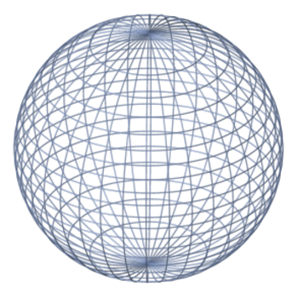
17. Volume: ____________ 18. Total amount & compound interest:
10m $1000 @ 6% per year for 15 years

(18.)Total:__________ Interest _________
(Bonus)
19. Reflection f(x) → –f(x) of point ( 7.5, –5.5): Location ___________ 20. Quadrant: ______

Determine the proportionally, slope and equation of table (a.).
(a.)
Price(x) Shipping Costs(y)

2.00 4 .00
3.50 7. 00
5.00 10 .00
6.50 13 .00
8.00 16 .00
Is table (a) Proportional? 21. ______________

What is the Slope for table (a)? 22. ______________

What is the equation for table (a)? 23. _______________
(slope intercept form)

